Deliverable D01: Workgroup Report

-

Group E8.02

## 

Github Repository: <https://github.com/JStockwell/Acme-One-E8.02>

Members:

* Gregorio Ortega Soldado ([greortsol@alum.us.es](mailto:greortsol@alum.us.es))
* Alejandro Manuel Gestoso Torres ([alegestor@alum.us.es](mailto:alegestor@alum.us.es))
* Jaime Stockwell Mendoza ([jaistomen@alum.us.es](mailto:jaistomen@alum.us.es))
* Pablo Aurelio Sánchez Valenzuela ([pabsanval1@alum.us.es](mailto:pabsanval1@alum.us.es))
* Manuel Cabra Morón ([mancabmor1@alum.us.es](mailto:mancabmor1@alum.us.es))
* Fernando Claros ([ferclabar@alum.us.es](mailto:ferclabar@alum.us.es))

## Fecha: 27/02/2022

# Table of Contents

| 1. Executive Summary 2. Revision Table 3. Introduction 4. Content    1. Workgroup Members    2. Formal Agreement    3. Self-Evaluation Methodology    4. Termination Clause    5. Signatures 5. Conclusions | 2  2  3  3  3  4  4  5  5  7 |
| --- | --- |

# Executive Summary

We are a group of 6 java developers, one of us also being the project manager of the team. We all are studying 3rd year in a software engineering degree and we have experience in projects due to other subjects like AISS, DP1, PSG1, IISSI1 and IISSI2.

Our product is a web information system which uses java technology, an IDE like Eclipse and 2 programs to interact with databases like MariaDB and DBeaver.

Our procedure is using github to establish a common cloud and a control version using branches that will commit to the main code and kanban boards to organize the work. We also use Scrum methodology to organize ourselves as a team.

# Revision Table

| Revision | Description | Date |
| --- | --- | --- |
| v1.0 | Initial Creation | dd/mm/YYYY |

# 

# Introduction

This report contains all of the formal agreements and self-evaluation systems that will be in place during the whole of the project's duration. The goal of such a document is to allow an easy introduction to the team in charge of the project, our outlook and predictions for the project and our self-evaluation methodologies.

# Content

## Workgroup Members

The E8.02 group is comprised of 6 members, all coursing the English class of Design and Testing 2.

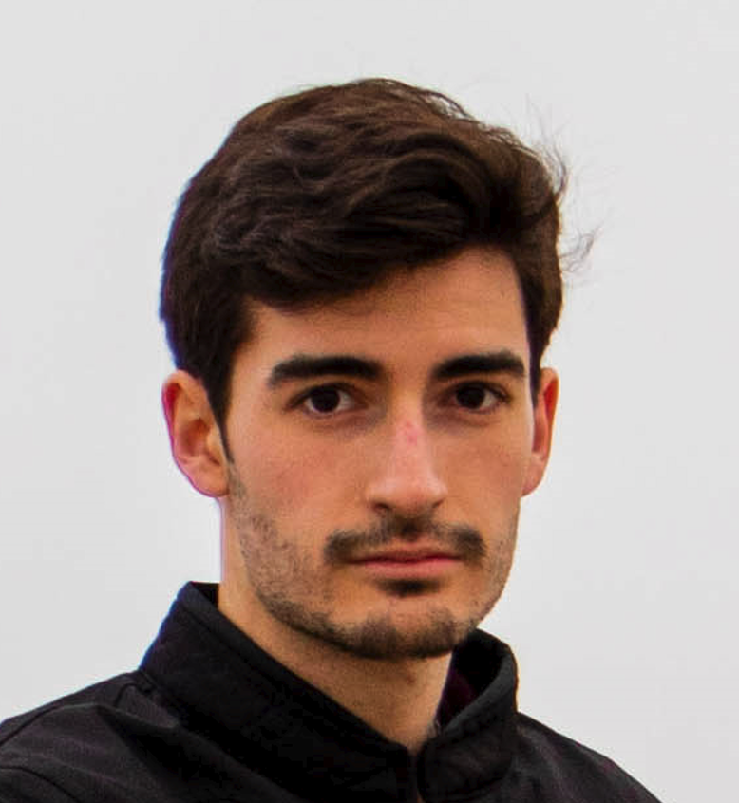

Gregorio Ortega Soldado

[greortsol@alum.us.es](mailto:greortsol@alum.us.es)

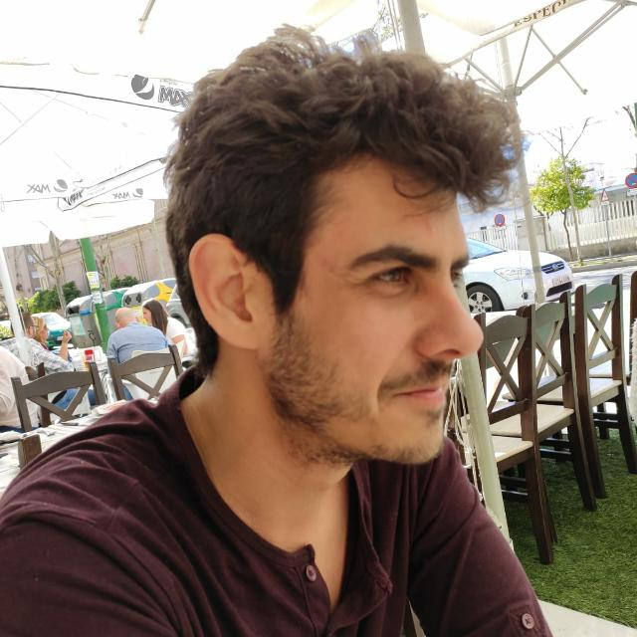

Alejandro Manuel Gestoso Torres

[alegestor@alum.us.es](mailto:alegestor@alum.us.es)

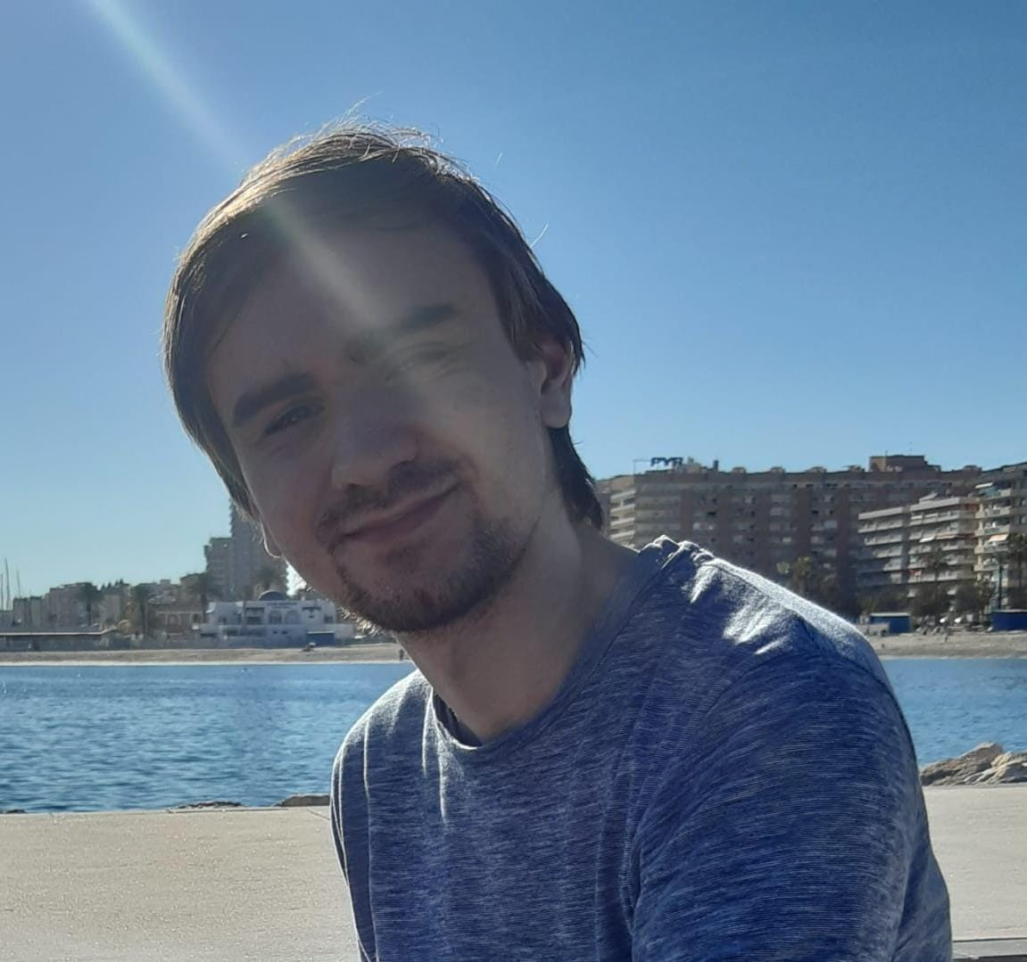

Jaime Stockwell Mendoza

[jaistomen@alum.us.es](mailto:jaistomen@alum.us.es)

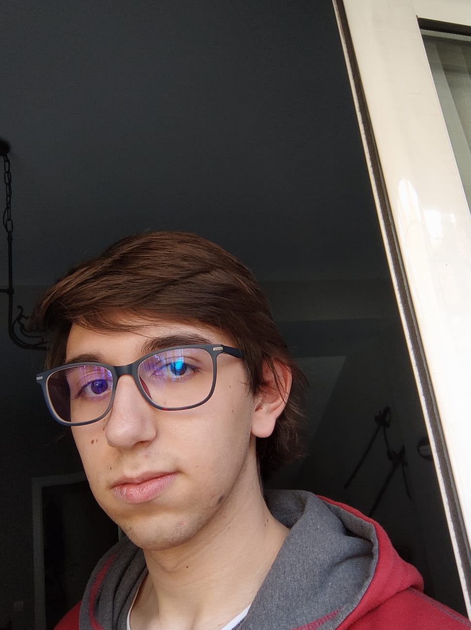

Pablo Aurelio Sánchez Valenzuela

[pabsanval1@alum.us.es](mailto:pabsanval1@alum.us.es)



Manuel Cabra Morón

[mancabmor1@alum.us.es](mailto:mancabmor1@alum.us.es)



Fernando Claros

[ferclabar@alum.us.es](mailto:ferclabar@alum.us.es)

## Formal Agreement

We, the E8.02 group, have read and understand the given syllabus for Design and Testing 2. After much deliberation, we have decided that we are going to attempt to achieve a 9 out of 10 mark in the final evaluation.

## Self-Evaluation Methodology

We will assign user story points using the poker system. With this in mind, we will set a weekly goal of user story points that must be met by each of the members of the group. As we are still a small group, we are open to reconfigure points assignments as the development continues or maintain external criteria in a case by case setting.

* Performing well: Complete all his story points. Does extra story points.
* Performing badly: Does not complete all his story points, does not attend the meetings.

As such, the outcomes from the performance of each member are:

* Reward: Less minimum story points assigned for the following week.
* Punishment: Extra minimum story points assigned for the following week.

## Termination Clause

If a team member completes less than 50% of the minimum story points in a period of 1 month, the rest of the team are in their right to remove them from the project. A reunion will be called with the rest of the team with and without the affected member to discuss the situation. At the end, the remaining members will vote on the decision.

## Signatures

Jaime Stockwell Mendoza:

Manuel Cabra Morón: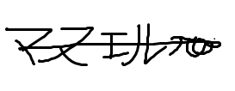

Pablo Aurelio Sánchez Valenzuela: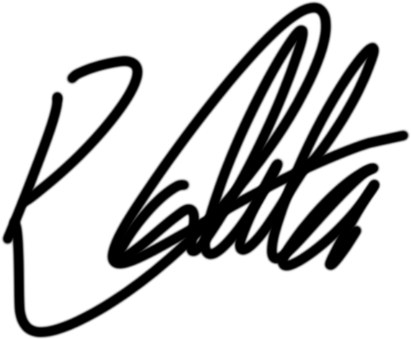

Alejandro Manuel Gestoso Torres:

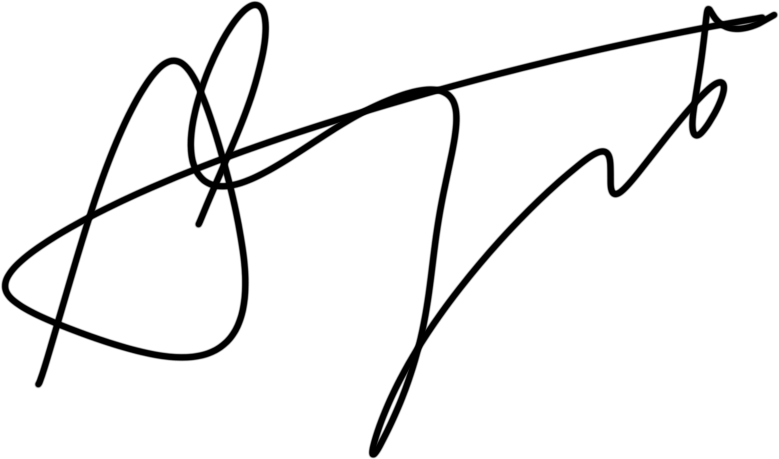

Gregorio Ortega Soldado:

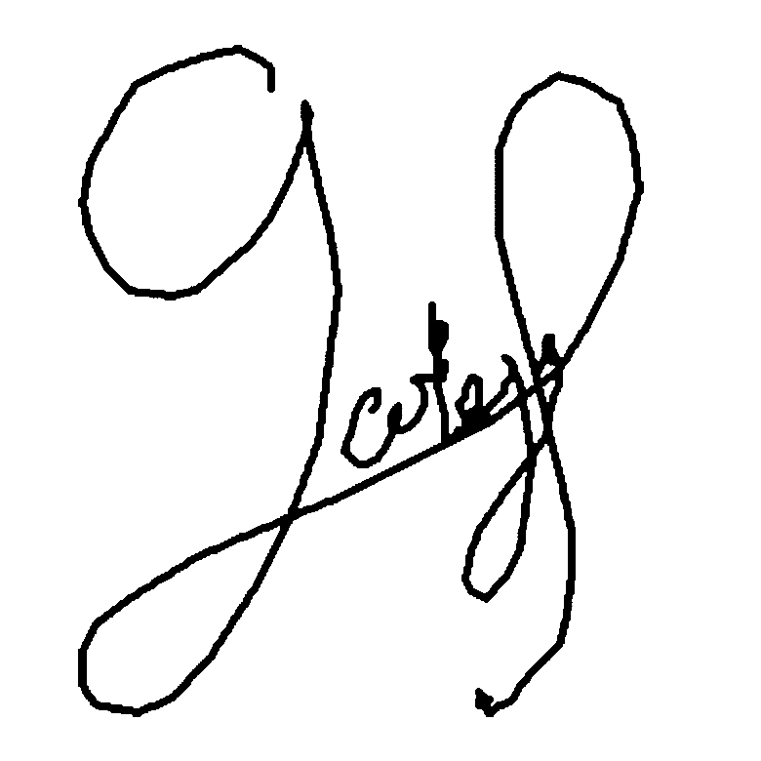

Fernando Claros:

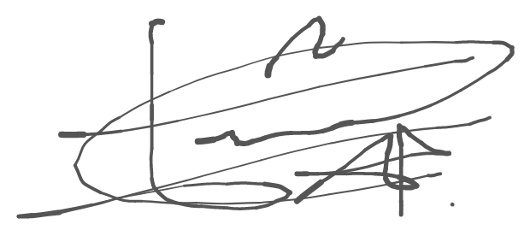

# 

# Conclusions

As a group, we strive to achieve a 9 out of 10 mark at the end of the semester, with help from the poker points assignment methodology and a good work ethic.